Monday, 22 January 2024

Dear Parents/Carers,

The Stephenson (MK) Trust Post 16 Centre is excited to invite your child to attend the Belfast Trip on Wednesday 20th March 2024.

We are asking for a contribution of £10 per students to secure their place. All food, drinks and attraction entrance fees on the day are included in this price.

Students will need to bring Photo ID to be able to travel on the day of the trip; this will need to be brought into school to be checked and copied, along with £10 payment, and completed medical form (attached), by Friday 26th January.

As much of the day will be outdoors, students will need to wear comfortable walking shoes and outerwear in case of rain – Crocs and sliders should not be worn. We will have a full trip meeting on Tuesday 19th March that all students taking part in the trip must attend to be briefed on behaviour and the expectations.

There will be a letter containing the full itinerary to follow; this will include the Titanic Museum, the Belfast Hop-on, Hop-off bus, Belfast Castle, the Crumlin Road Gaol and other sites in this incredible city.

Should your child still need to acquire photo ID between now and March, please contact the centre to advise us of this.

We are looking forward to sharing this day with them to see a city so rich in history and culture.

Yours faithfully,

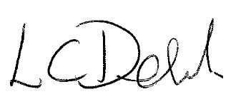

Ms C Dehnel
Assistant Principal
Post 16 Centre

